# **Compatibility testing**

**Checking the functionality of an application on different software, hardware platforms, network, and browsers is known as compatibility testing**

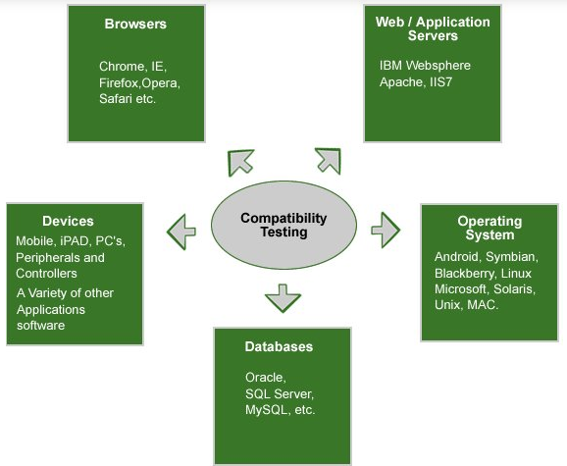

**Eg. Application tested on Win 2000 platform**

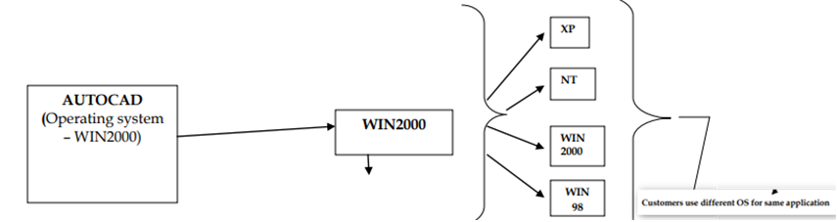

**This testing process will ensure that the software is compatible across operating systems, hardware platforms, web browsers, etc.**

The application could also impact due to different versions, resolution, internet speed and configuration etc. Hence it’s important to test the application in all possible manners to reduce failures and overcome embarrassments of bug’s leakage. As a Non- functional tests, Compatibility testing is to ensure that the application runs properly in different browsers, versions, OS and networks successfully.

The main intention behind performing testing is to make sure that the software is working fine in any kind of platform/software/configuration/browsers/hardware etc.

The compatibility test is conducted under different hardware and software application conditions, where the computing environment is important, as the software product created must work in a real-time environment without any errors or bugs.

Some of the main computing environments are the operating systems, hardware peripherals, browsers, database content, computing capacity, and other related system software if any.

**This testing is done only when the application becomes stable.**

**Types of Compatibility Testing**

1) **Forward testing** makes sure that the application is compatible with updates or newer mobile operating system versions.

2) **Backward testing** checks whether the mobile app has been developed for the latest versions of an environment and also work perfectly with the older version. The behavior of the new hardware/software has been matched against the behavior of the old hardware/software.

**While doing compatibility testing from web based application point of view**

We test on different OS

We test on different browsers. Also test on different version of browsers

We test on different networks

**Compatibility testing is conducted in mobile applications for the following reasons:-**

This testing is performed to make sure that the final app product performs as expected on various mobiles/devices of different make and models

This is a type of non-functional testing whose main aim is to check the compatibility of applications with browsers, mobiles, networks, databases, operating systems, hardware platforms, etc.

With this testing, a tester can detect any error before the final launch of the mobile application in the market

**Categories of Compatibility Testing**

* **Hardware** –It checks software to be compatible with different hardware configurations.
* **Operating system** – It checks your software to be compatible with different Operating Systems like Windows, Unix, Mac OS etc.
* **Network** – Evaluation of performance of a system in a network with varying parameters such as Bandwidth, Operating speed, Capacity. It also checks application in different networks with all parameters mentioned earlier.
* **Devices** – How the software is performing across various devices
* **Versions** – To check the compatibility across various versions of OS across devices backward and forward compatibility testing has to be performed

**Advantages of Compatibility Testing**

* Customer complaints can be avoided in the future
* Feedback in the testing stage will enhance the development process
* Reputation and goodwill of the company will increase

**How to do Compatibility Testing**

* Have a clear idea about the platform the app will be working on
* The person and team involved in the process must have good platform knowledge
* Set up the environment and before the actual test do a trial run.
* Report the issues properly and make sure that it has been rectified. If you are finding new bugs make sure that after the rectification old fix is working fine.

**Tools for Compatibility Testing**

* CrossBrowserTesting.com
* Lambda Test
* BrowserStack
* Virtual Desktops
* Browser Sandbox
* Ranorex Studio
* TestComplete
* Browsera

**There are some most common defects which can be found**

* Differences in the UI with respect to appearance and feel,
* issues with font size and alignment,
* concern with respect to Scroll Bar and marked changes in CSS style and color,
* issues like broken tables or frames, etc.
* Look and feel issues
* Font size issues
* Alignment issues
* Broken frames
* 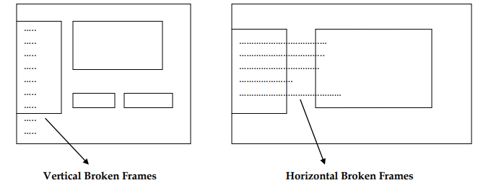
* Object overlapping
* 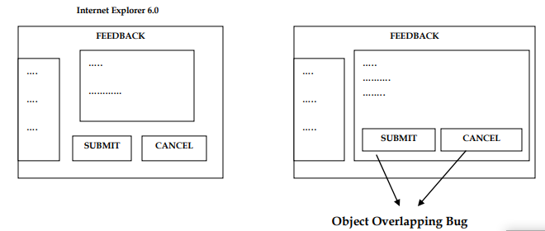

Scattered Content

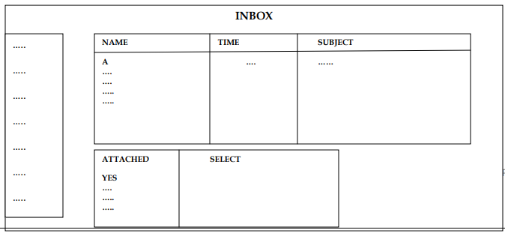

# **Cross Browser Compatibility Testing Checklist**

### **Layout and Design:**

* Checking the design, style, layout and presentation consistency across all the browsers.
* To check that if images are in their standard resolutions and proposed alignment on each browser or not.
* Font with its attributes such as colour, size formatting etc., which were actually implemented and used, is working identically for all the browsers.
* Checkboxes, radio buttons, forms are aligned correctly.
* Ensuring website's responsive quality across each targeted browser.
* Proper spacing between sections, fields, paragraphs, images and data contents.
* Horizontal and Vertical scroll bar appearance.
* Zoom-in and Zoom-out the web pages.
* Drop down Menus: Verify that the drop downs work as expected across all browsers
* Proper navigation between the web pages.
* Mouse Hover and tool tips.
* Ensuring a good number of audio and video formats to support media files/data for each different browser.
* Checking the alignment of data content on the web pages.
* Consistency in the colour and contrast across all different browsers.
* To check out the header and footer layout of the web pages.

### 

### **Functionality:**

* Whether plug-ins required for the web application is supported by all the browsers or not.
* Uploading or Downloading any file or image or data in multiple formats.
* Testing the navigation links, search option and error page.
* Validating the different functionalities like form submit, saving the data, importing or exporting file, etc.
* Animation and flash work consistency.
* **Pop Ups:** Check if the pop ups are being displayed properly and are opening in all browsers.
* Interaction with web pages through mouse, keyboard, etc. in a similar way for all the browsers.
* Validating the working of the scripts used in the website across all targeted browser.
* Performance of the web application on different browsers for multiple variants of load.
* Validating the forms and fields for each different browser.

**What is the purpose of compatibility testing?**

Compatibility testing is used to determine if your software application has issues related to how it functions in concert with the operating system and different types of system hardware and software.